**Assignment - 3**

|  |  |
| --- | --- |
| STUDENT NAME | ABINAYASRI M |
| TEAM ID | PNT2022TMID30875 |

**Question-1:**

Create a Bucket in IBM object storage.

# Solution:

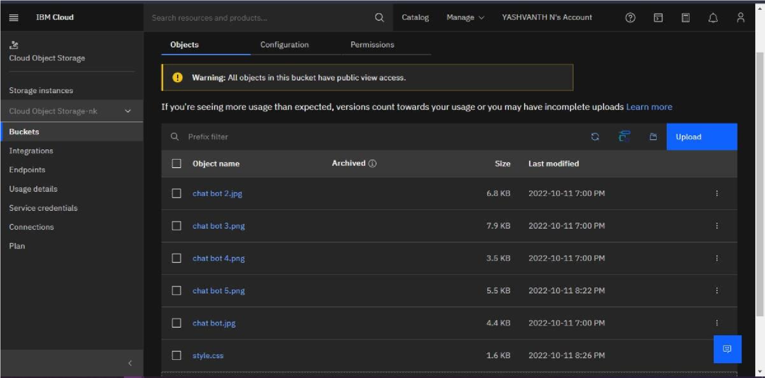

**Question-2:**

Upload an 5 image to IBM object storage and make it public. Write html code to displaying all the 5 image.

# Solution:

<!DOCTYPE html>

<html lang="en">

<head>

<meta charset="UTF-8">

<meta http-equiv="X-UA-Compatible" content="IE=edge">

<meta name="viewport" content="width=device-width, initial-scale=1.0">

<title>Bucket</title>

</head>

<body>

<img src="https://s3.au-syd.cloud-objectstorage.appdomain.cloud/mybucket24/chat%20bot.jpg"> <img src="https://s3.au-syd.cloud-objectstorage.appdomain.cloud/mybucket24/chat%20bot%202.jpg">

<img src="https://s3.au-syd.cloud-objectstorage.appdomain.cloud/mybucket24/chat%20bot%203.png">

<img src="https://s3.au-syd.cloud-objectstorage.appdomain.cloud/mybucket24/chat%20bot%204.png">

<img src="https://s3.au-syd.cloud-objectstorage.appdomain.cloud/mybucket24/chat%20bot%205.png">

</body>

</html>

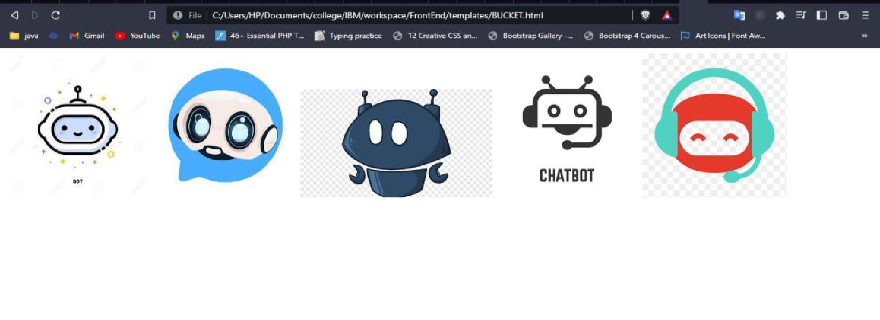

**Question-3:**

Upload a CSS page to the object storage and use the same page in your HTML code. Write html code to displaying all the 5 images.

# Solution:

|  |
| --- |
| <html>  <head>  <meta charset="utf-8">  <meta name="viewport" content="width=device-width, initial-scale=1, shrink-to-fit=no">  <link rel="stylesheet" href="https://maxcdn.bootstrapcdn.com/fontawesome/4.7.0/css/fontawesome.min.css">  <link rel="stylesheet" href="https://stackpath.bootstrapcdn.com/bootstrap/4.5.0/css/bootstrap.min.css ">  <link rel="stylesheet" href="https://cdnjs.cloudflare.com/ajax/libs/particlesjs/2.2.3/particles.min.j s">  <link rel="stylesheet" href="https://s3.au-syd.cloudobjectstorage.appdomain.cloud/mybucket24/style.cssxxxxxxxxxxxxxxxxxx x">  </head> |

<body>

< div = “signup” >

<form action="\result" method="post">

<h2>LOGIN</h2>

<div class="form-group">

<div class="input-group">

<span class="input-group-addon”><i class = "fa faenelope”></i></span>

<input type="email” name="email” class="formcontrol” placeholder="Email” required>

</div>

</div>

<div class="form-group">

<div class="input-group">

<span class="input-group-addon”><i class = "fa faenelope”> </i></span>

<input type="password” name="password” class="formcontrol” placeholder="password” required>

</div>

</div>

<div class="form-group">

<button type="submit” class = "btn btn-primary btn-lg btnblock ”>Login</button>

</div>

</body>

</html>

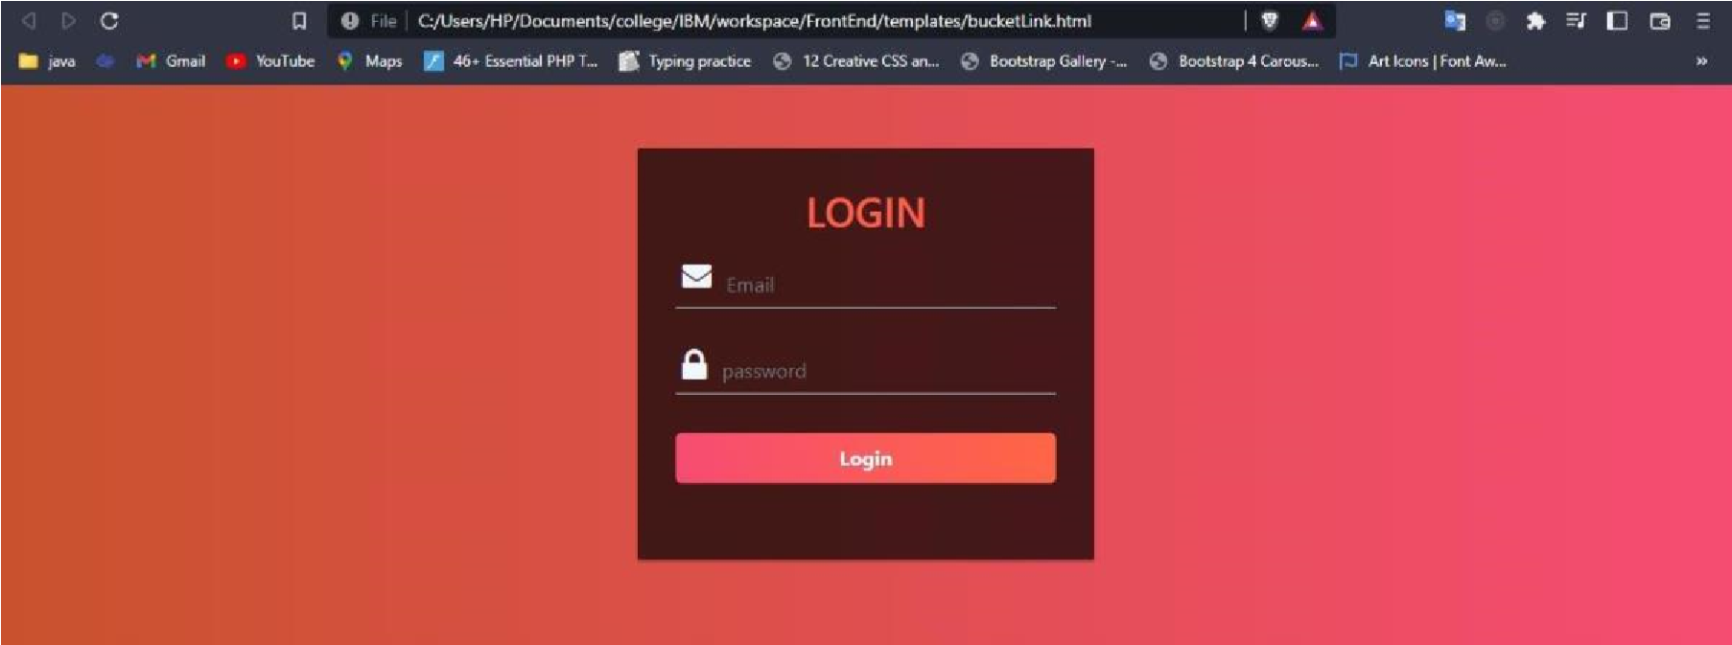

**Question-4:**

Design a chatbot using IBM Watson assistant for hospital. Ex: User comes with query to know the branches for that hospital in your city. Submit the web URL of that chat bot as assignment.

# Solution:

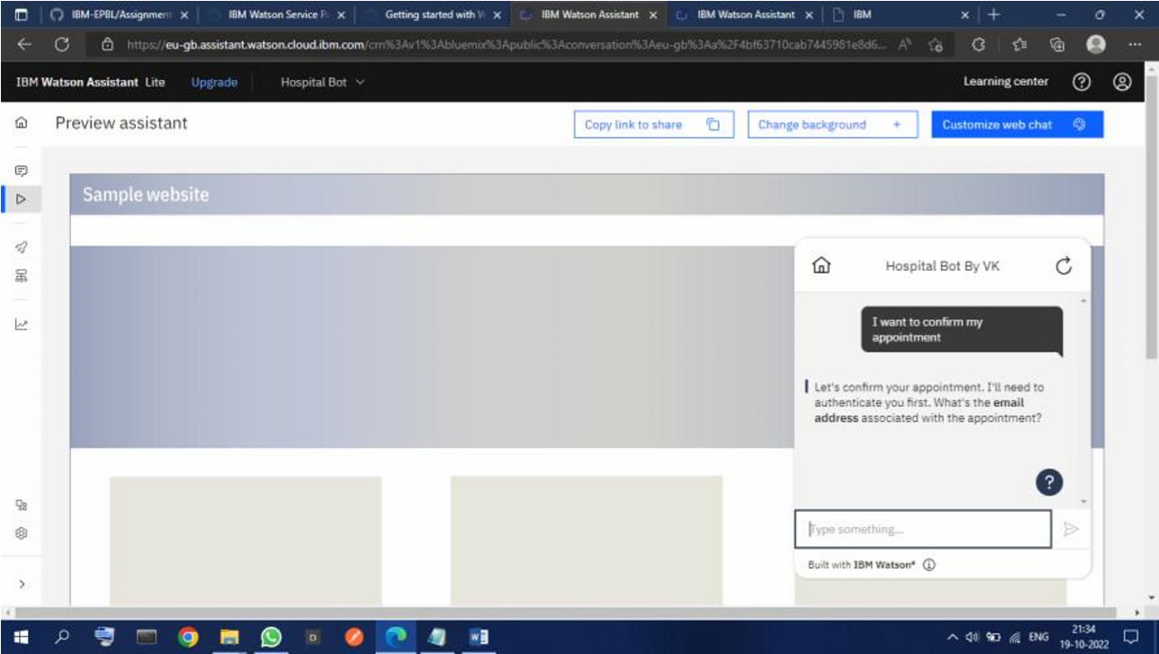

**Question-5:** Create Watson assistant service with 10 steps and use 3 conditions in it. Load that script in HTML page.

Solution:

<!DOCTYPE html>

<html><head>

<meta name="viewport" content="width=device-width, initial-scale=1.0">

<title>Chatbot </title> <link rel="stylesheet"

href="https://cdn.jsdelivr.net/npm/bootstrap@4.6.2/dist/css/bootstrap.min.css" integrity="sha384-

xOolHFLEh07PJGoPkLv1IbcEPTNtaed2xpHsD9ESMhqIYd0nLMwNLD69Npy4HI+N"

crossorigin="anonymous">

<link rel="stylesheet" href="{{url_for('static',filename='styles/login.css')}}" type="text/css">

<link rel="preconnect" href="https://fonts.googleapis.com">

<link rel="preconnect" href="https://fonts.gstatic.com" crossorigin>

<script defer src="https://use.fontawesome.com/releases/v5.13.1/js/all.js"></script>

<link

href="https://fonts.googleapis.com/css2?family=Alex+Brush&family=Quicksand:wght@300&displ

ay=swap" rel="stylesheet">

</head>

<body style="background:rgba(128,0,128,0.2">

<h1 style="font-weight: bolder;

margin: 12%;

font-size: xxx-large;">Building Chatbot For Hospital</h1>

<script> window.watsonAssistantChatOptions = { integrationID: "cba0c163-9f9a42ce-b6e9-979ac6318cc0", // The ID of this integration. region: "au-syd", // The region

your integration is hosted in serviceInstanceID: "245858a6-01a2-41fc-8707-d603be17b8f0", // The ID of your service instance. onLoad: function(instance) { instance.render(); }

};

setTimeout(function(){

const t=document.createElement('script');

t.src="https://web-chat.global.assistant.watson.appdomain.cloud/versions/" +

(window.watsonAssistantChatOptions.clientVersion || 'latest') + "/WatsonAssistantChatEntry.js";

document.head.appendChild(t); }

);

<\body>

<\html>

